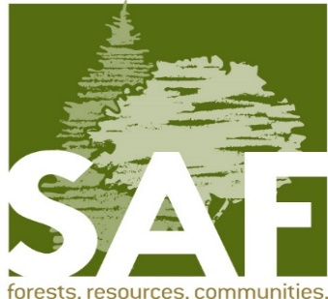
Southeast Chapter
May 22, 2018

A changing climate has foresters and other resource professionals looking for management options as we deal with these environmental stresses to our forests. Join us to learn about the efforts of the USDA Forest Service.

Presentation
Assisted Migration and Genetic Options for Adapting to Climate Change
Paul Berrang
Regional geneticist, USDA Forest Service

When: May 22 - Tuesday, 6:30
Where: Hartland Public Library, 110 E. Park Ave. Hartland WI
Questions?/ RSVP Jeff Kante 262 719-0702

