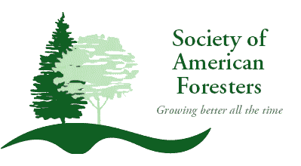
2019 Great Lakes SAF Leadership Conference Agenda
June 9, 10 & 11
Fox Valley Technical College (FVTC) - Appleton Campus
1825 N Bluemound Drive
Appleton, WI 54912

June 9, 2019 - Comfort Suites, Commons Area
5:00 pm - Check-in/Registration

6:00 pm - Welcome, introductions, opening remarks Anthony Rynish

6:15 pm - Ice, breaker Chris Jossart

7:30 pm - Program overview and goals Chris Jossart

8:00 pm - Adjourn and relax

June 10, 2019 - FVTC - Appleton Campus, Room HS 301
7:00 am - Breakfast, registration

8:00 am - Welcome and introduction of morning arrivals Anthony Rynish

8:15 am - Twenty Floors Down – Leadership Primer Chris Jossart
10:00 am – Break

10:15 am - Twenty Floors Down – Leadership Experience Chris Jossart

11:45 am - Lunch

1:00 pm - Twenty Floors Down – Leadership Discoveries Chris Jossart

2:45 pm – Break
3:00 pm - Twenty Floors Down – Next Steps Chris Jossart
5:00 pm – Adjourn for Dinner

6:00 pm - Move location to local establishment
6:15 pm - Question and answer session with SAF CEO Terry Baker, SAF President John McNulty,
and District 5 Representative Don Howlett.
Topics for Discussion
- Local Leadership and Recruitment
- State Society Position Roles and Responsibilities
- Professional Ethics

7:15 pm - Networking session

8:00 pm - Adjourn, relax

June 11, 2019 - FVTC - Appleton Campus, Room HS 301
7:00 am - Breakfast

8:00 am - Welcome, Introduction of first speaker Anthony Rynish

8:15 am – Leading From Where You Are Terry Baker

9:00 am - Leadership Lessons John McNulty

9:45 am - Break

10:00 am - Mentoring at the Chapter and State Society Gary Vander Wyst
How to Conduct a Meeting/Parliamentary Procedure

10:45 am - Building and Maintaining Effective Partnerships Don Howlett

11:30 am - Complete SAF Feedback Sheets Clark Seeley

12:00 pm - Adjourn conference

This conference qualifies for 11 CFE’s (Category 1) for SAF Certified Foresters.

This conference qualifies for 11 Continuing Education Hours for Wisconsin Cooperating Foresters.

